**INTI International College Penang School of Computing**

**3+0 Bachelor of Science (Hons) in Computer Science, in collaboration with Coventry University, UK**

# Coursework cover sheet

**Section A - To be completed by the student.**

|  |  |
| --- | --- |
| Full Name: SHARON TAN | |
| CU Student ID Number: 14007547 | |
| Semester: 2 | |
| Session:  **April 2023** | |
| Lecturer:  **Puteri Nursyawati Azzuri (puteri.azzuri@newinti.edu.my)** | |
| Module Code and Title:  **4067CEM Software Design** | |
| Assignment No. / Title:  **Continuous Assessment** | % of Module Mark:  **50** |
| Hand out Date:  **12 May 2023** | Due Date:  **Task 1: 04 June 2023, by 11.59pm.**  **Task 2: 07 July 2023, by 11.59pm**  **Task 3: 07 July 2023, by 11.59pm.**  **Task 4: 07 July 2023, by 11.59pm.**  **Task 5: 07 July 2023, by 11.59pm.** |
| Penalties: No late work will be accepted. If you are unable to submit coursework on time due  to extenuating circumstances, you may be eligible for an extension. Please consult the lecturer. | |
| Declaration: I/we the undersigned confirm that I/we have read and agree to abide by the University regulations on plagiarism and cheating and Faculty coursework policies and procedures. I/we confirm that this piece of work is my/our own. I/we consent to the appropriate storage of our work for plagiarism checking.  Signature(s): | |

# Section B - To be completed by the module leader

|  |  |  |
| --- | --- | --- |
| Intended learning outcomes assessed by this work:   1. Understand and apply appropriate concepts, tools, and techniques to each stage of the software development. 2. Understand and apply design patterns to software components in developing new software. 3. Demonstrate an understanding of project planning and working to agreed deadlines, along with professional, interpersonal skills and effective communication required for software production.   5. Demonstrate an awareness of, and ability to apply, social, professional, legal, and ethical standards as documented in relevant laws and professional codes of conduct such as that of  the Malaysian National Computer Confederation. | | |
| Marking scheme | Max | Mark |
| 1. User Story Mapping | 20 |  |
| 2. Setting up a GitHub |  |
| Repository | 10 |
| 3. Creating a Class diagram and |  |
| design pattern selection | 30 |
| 4. Creating a Prototype User |  |
| Interface and Usability Testing | 20 |
| 5. Discuss the ethical issue |  |
| related to the software | 20 |
| Total | 100 |  |

**Table of Contents**

|  |  |  |
| --- | --- | --- |
| No. | Title | Page |
| 1. | Introduction | 1 |
| 2. | Task 1 – User Story Mapping | 2 - 7 |
| 3. | Task 2 – Setting up a GitHub Repository | 8 |
| 4. | Task 3 – Creating a Class diagram and design pattern selection | 9-12 |
| 5. | Task 4 – Creating a Prototype User Interface and Usability Testing | 13-30 |
| 6. | Task 5 – Discuss the ethical issue related to the software | 31-33 |
| 7. | Conclusion | 34 |
| 8. | References | 35 |

**Introduction**

This assessment is focused on designing a Student Business System for College. The term ‘business’ comes with different definitions. Based on Cambridge Dictionary, business means the commercial activities carried out by someone to earn profits by providing goods and services. On the other hand, it can also be defined as things or activities to do that are related to someone (Business, 2023). In further research, it is found that the term ‘Student Business System’ is used by Australian National University and Swinburne University of Technology as a system providing administration and academic services for their students (Student Business Systems, Swinburne University of Technology, 2023; Student Business Systems, Australian National University, 2023).

There are 5 tasks to be completed as for the design process. The assessment begins with the feedback collection from at least 10 real users for the features and functionalities of the system. Information collected is then interpreted to generate a user story mapping. A class diagram is then designed with the clarification of each class’s responsibilities. Based on that, a Unified Modelling Language (UML) diagram is created with a suitable design pattern for solving a specific problem. Now the process comes to the task of prototyping and followed by list out questions for usability testing. After all of the above tasks are done, an analysis needs to be carried out critically about the ethical issues of the system. Lastly, a GitHub repository is created to organize all the works and make sure not exceeding the due date.

Overall, this assessment is planned to create comprehensive designs for the Student Business System for College mainly based on the preferences of real users, the college students. For example, user story mapping, UML diagram as the class diagram and the prototype. The purpose of this system is to enhance the effectiveness of a college institution as well as improve student experiences.

**Task 1 – User Story Mapping**

**1.0 Data collection**

Google Forms is used in this assessment to collect the feedback of real users toward the Student Business System for College. The link is sent through conversations and extra information is given when the respondents meet any problems or questions when answering the survey forms. As a result, there are 15 responses with at least 10 different features hoped by them as a user. The survey form is closed after obtaining all the required information.

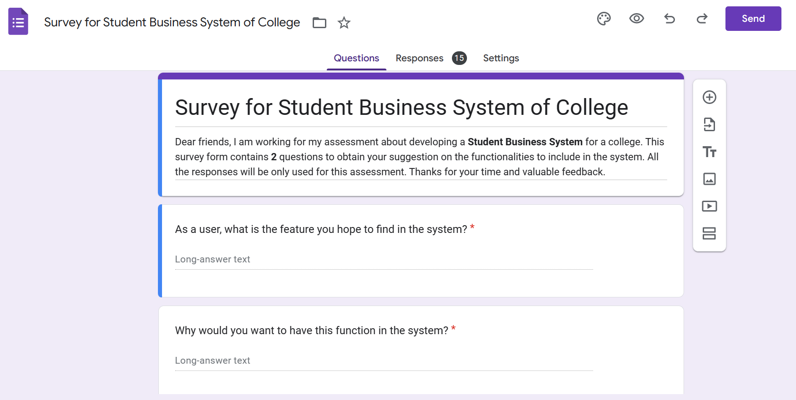

Figure 1.0: The figure shows the title, description and questions of the survey form.

**1.1 Data categorization**

As there are some similar responses in the survey forms for the features in question 1, hence Trello is used for better organization and categorization. The answers of question 1 are used as the list’s title and respective answers in question 2 are recorded in the card.

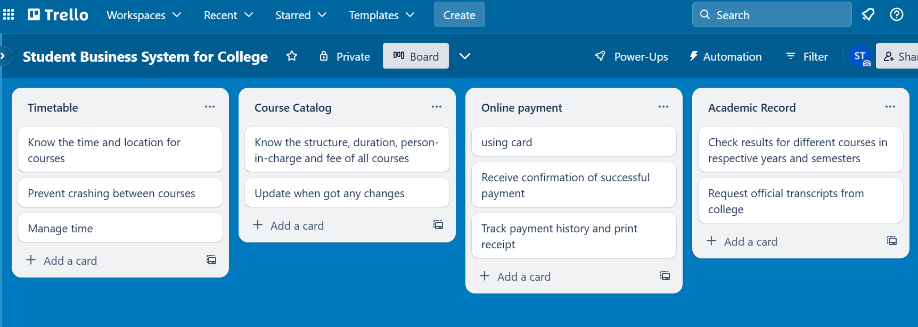

Figure 1.1: The figure shows the categorization of responses from survey form.

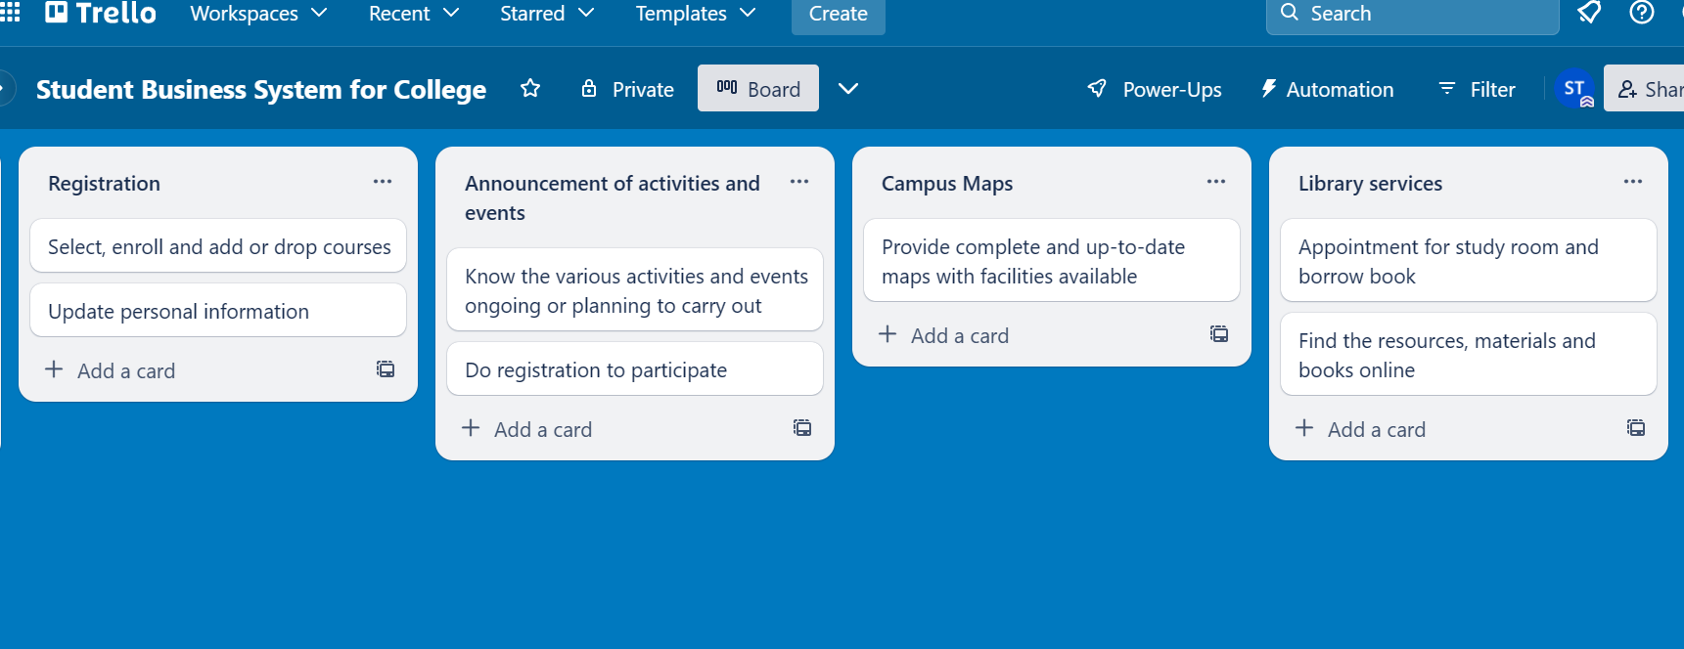

Figure 1.2: The figure shows the categorization of responses from survey form.

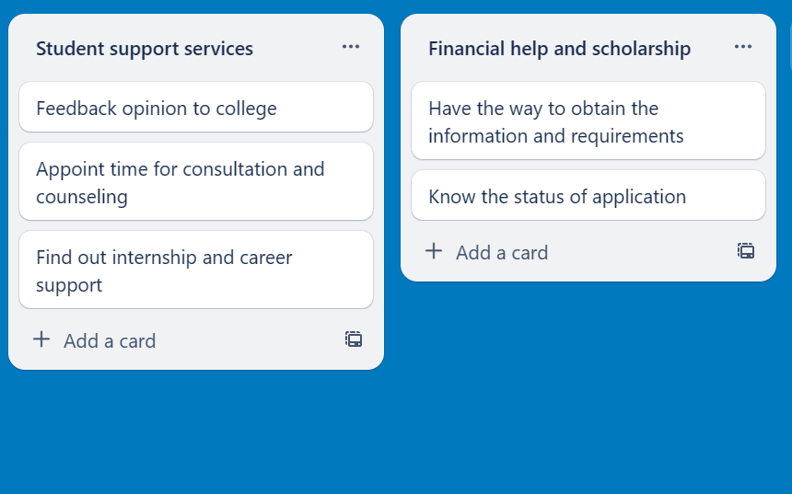

Figure 1.3: The figure shows the categorization of responses from survey form.

**1.2 User stories and backlog**

Based on what has been done in Trello, 10 user stories and respective backlog are generated with small modifications for fluency. Basically, the different features in the title are used as the activities to be performed by users and the reasons for having these features in the card are the goals aimed to achieve.

User Stories

1. As a user, I want to look for my timetable so that I can know the time and location for courses, prevent crashing between courses and better time management.

2. As a user, I want to find out the course catalog so that I can know the structure, duration, person-in-charge and fee of all courses. Update is needed when there are any changes.

3. As a user, I want to pay the fees online by using cards so that I can easily track payment history and print receipts. I hope to receive confirmation after a successful payment.

4. As a user, I want to check my academic record so that I can access my results for different courses in specific years and semesters and also request official transcripts from college.

5. As a user, I want to do my registration so that I have the ability to select the courses to enroll, add or drop. I also hope that I can update my personal information.

6. As a user, I want to receive the announcements of activities and events so that I can participate by quickly registering for the various activities and events that are ongoing or planned to be carried out by college.

7. As a user, I want to access complete and up-to-date online campus maps so that I get familiar with campus faster. The maps should include all the facilities available as well.

8. As a user, I want to access library services online so that I can quickly find the resources, materials and books in the library. I hope there is also an appointment feature for a study room and borrowing book.

9. As a user, I want to easily access student support services so that I can provide feedback to college, schedule consultations or counseling sessions and also find information about internships and career opportunities.

10. As a user, I want to find out information about financial aids and scholarships so that I can obtain requirements for application and track the status of application.

Backlog

Goals:

1. Know the time and location for courses, prevent crashing between courses and better time management.

2. Know the structure, duration, person-in-charge and fee of all courses with updates when there are any changes.

3. Easily track payment history, print receipt and receive confirmation after a successful payment.

4. Access results for different courses in specific years and semesters and also request official transcripts from college.

5. Have ability to select the courses to enroll, add or drop and update personal information.

6. Participate by quickly registering for the various activities and events that are ongoing or planning to carry out by college.

7. Get familiar with campus faster with the maps including all the facilities available.

8. Quickly find the resources, materials and books in the library besides appointment for study room and borrowing book.

9. Provide feedback to college, schedule consultations or counseling sessions and also find information about internships and career opportunities.

10. Obtain requirements for application and track the status of application.

Activities:

1. Look for a timetable.

2. Find out the course catalog.

3. Pay fees online by using cards.

4. Check academic record.

5. Do registration.

6. Receive announcements of activities and events.

7. Access complete and up-to-date online campus maps.

8. Access library services online.

9. Easily access student support services.

10. Find out information about financial aids and scholarships.

Tasks:

1. Timetable page – Select year and semester

2. Catalog page – Select a course from the list

3. Payment page – Pay for selected courses

4. Academic page – Select year and semester

5. Log In – Personal information – Enrollment page – Select courses

6. Activities and Events page – Click on an activity or event

7. Maps page – Click on different blocks or floors

8. Library page

9. Student support services page

10. Financial Aids and Scholarships page – Select a financial aids or scholarship program

**1.3 User story mapping**

For the next step, Figma is utilized to create the user story mapping to provide a complete overview of the system. It included sections of person, goals, activities, tasks and releases. Each of the sections is represented using distinct colours of sticky notes. The arrangement of sticky notes is important to clarify the relationship between each other.

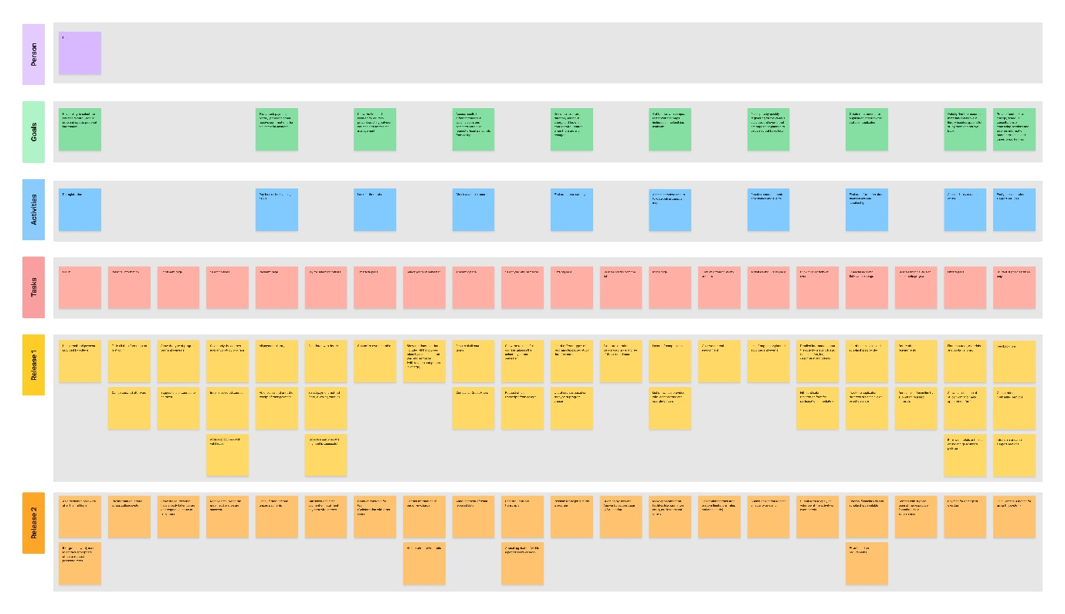

Figure 1.4: The figure shows the overall view of user story mapping for the system.

Link for user story mapping: <https://www.figma.com/file/dtc90gPX9GJrDijUBtsA6x/Student-Business-System-for-College?type=whiteboard&node-id=0%3A1&t=nEPkMrroz4vzxCXg-1>

**Task 2 – Setting up a GitHub Repository**

GitHub link: <https://github.com/xsharonxx/SharonTan_P22014778_4067CEM.git>

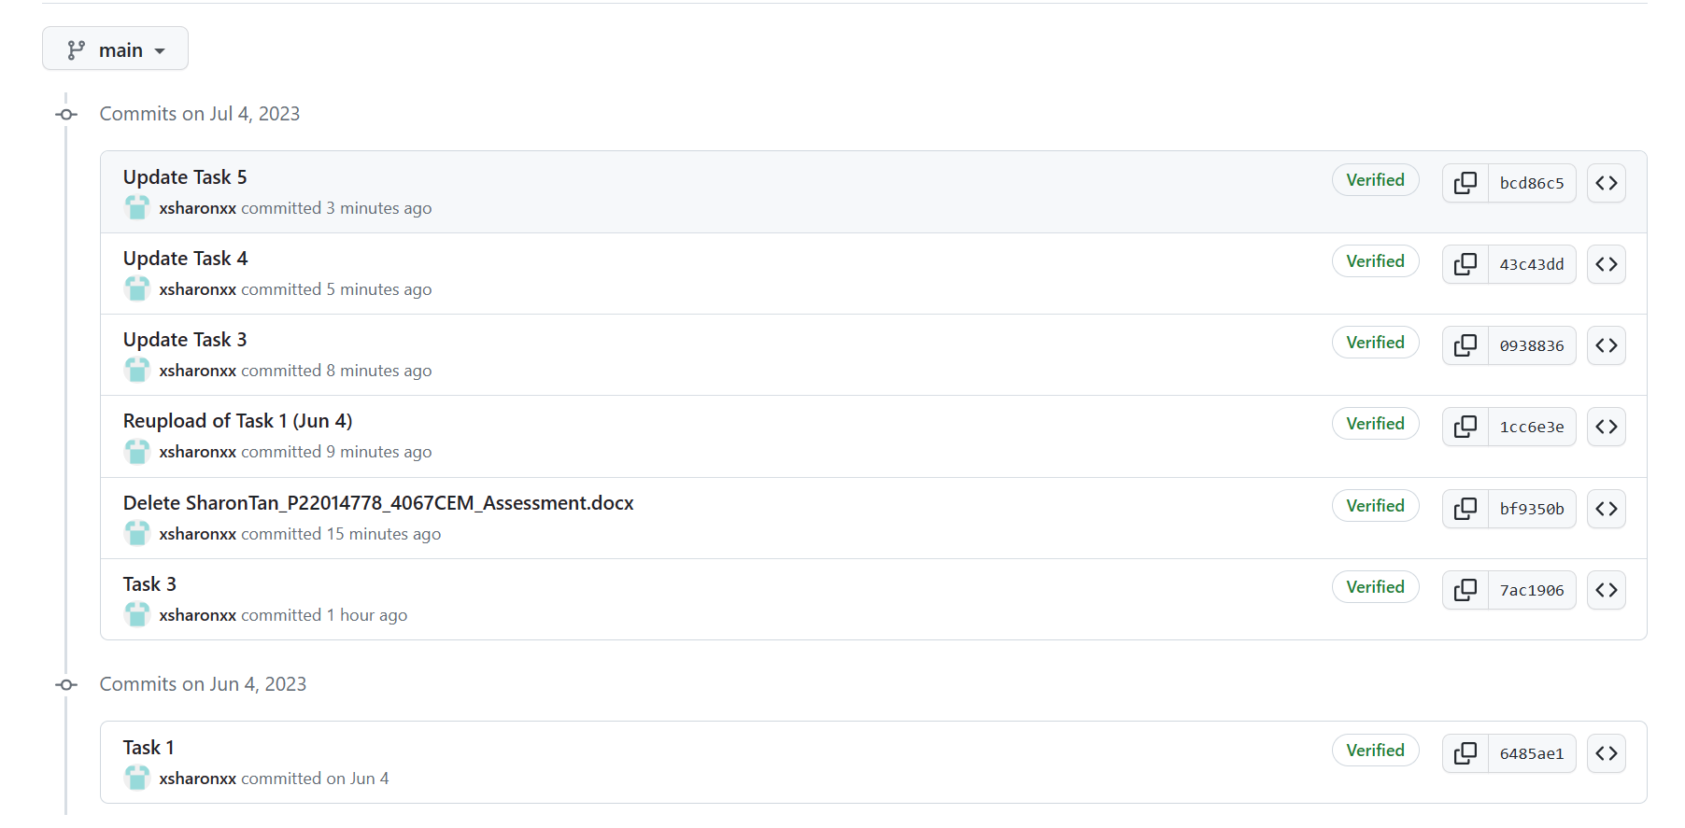

Figure 2.0: The figure shows the commits history of the repository.

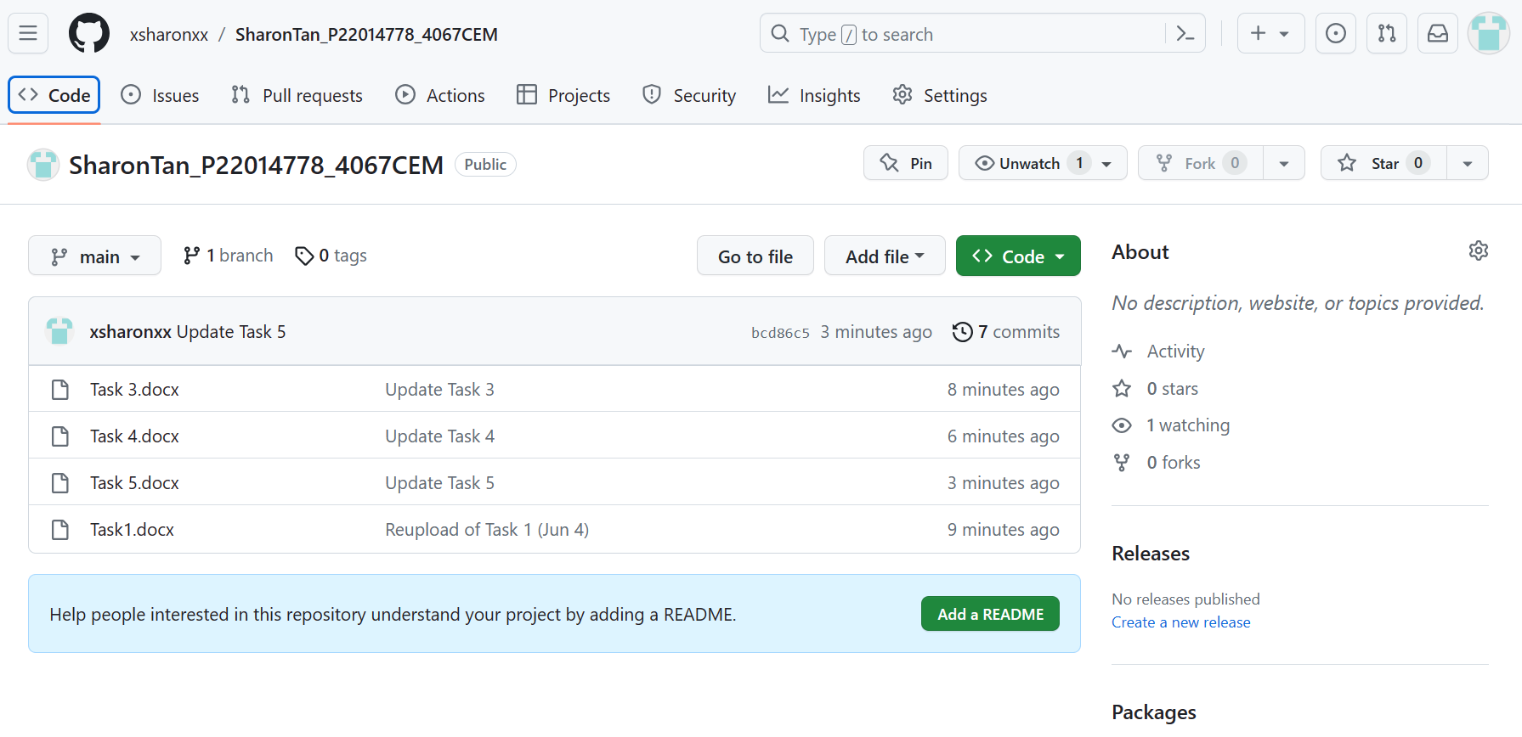

Figure 2.1: The figure shows the files uploaded in the repository.

Initially when adding files into GitHub, both files for task 1 and task 3 have the same name of ‘SharonTan_P22014778_4067CEM_Assessment’, causing the replacement of the task 3 file over task 1 file. Therefore, the file is being deleted, renamed and uploaded again. The commits history is shown for better clarification.

As the final result, the repository with the title of ‘SharonTan_P22014778_4067CEM’ in GitHub now has respective files for task 1, task 3, task 4 and task 5. The file of task 2 will be uploaded afterwards.

**Task 3 – Creating a Class diagram and design pattern selection**

**3.0 Class diagram**

A class diagram is created based on the user story mapping above using Draw.io. The main purpose is to visualize the structures of the Student Business System for College. By having the classes blocks, relationships, roles and multiplicities, it enhances developers’ understanding and facilitates development process.

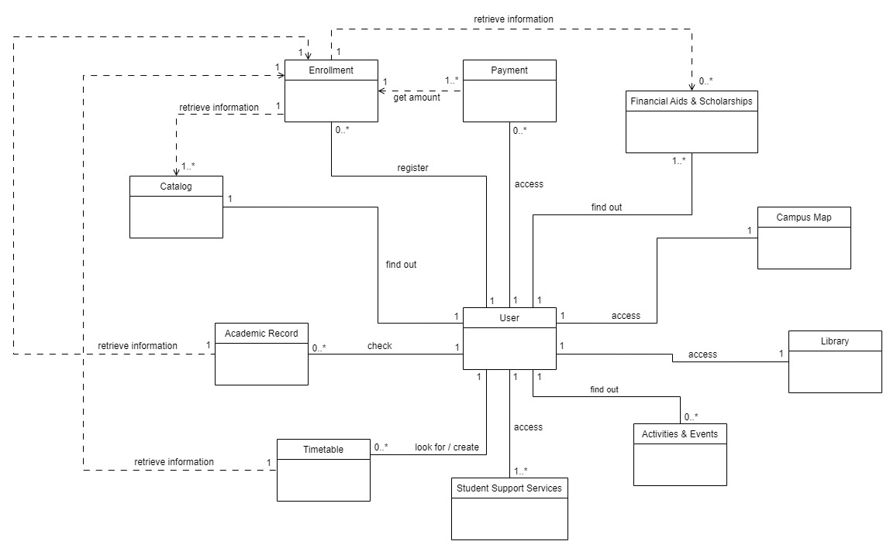

Figure 3.0: The figure shows the class diagram created for the system.

**3.1 Responsibilities of classes**

User

Responsible for storing personal information of users such as name, age, email, password, address, school and program taken. It acts as a basic foundation for user authentication. Only the person having the user account is able to have access to the system.

Enrollment

Enables users to carry out registration for a new semester. It manages and verifies the processes of enrolling in, adding and dropping courses. The class retrieves information from Catalog class to obtain details and fees of all the selected courses. It will also retrieve information from the Financial Aids & Scholarships class to determine whether the user has any approved aids or scholarships to be applied.

Payment

Manages transaction information for each payment. It stores histories and details of all payments such as status, date, payer, payee and amount. The total amount to be paid depends on the fees calculated in Enrollment class. It enables users to pay off once or in batches. Payment of fines are also handled by this class.

Timetable

Stores information of timetables, including auto-generated timetables which are based on the enrolled courses retrieved from Enrollment class and also timetables created by users themselves. It allows users to organize and personalize the timetables according to their own planning and preferences.

Academic Record

Responsible for storing all relevant information about the user’s academic progress such as results, courses taken and cumulative credit hours. It retrieves enrolled courses from Enrollment class as well for updating respective records. Additionally, it facilitates the processes of requesting official transcripts and appealing.

Catalog

Stores the information of all the programs and courses available in the college. For example, structure, duration, fee, lecturer and requirement. It provides real-time communication between users and responsible personnel for solving confusions.

Campus Map

Stores information about the college campus, from buildings, floors to rooms. It included the operating hours, booking options and rules and regulations of each facility within the campus.

Activities & Events

Responsible for managing information such as date, time, venue and organizer about various activities and events to be carried out. It will send out announcements to encourage users to register for joining those activities and events.

Financial Aids & Scholarships

Manages information of financial aids and scholarships offered by the college or external organizations. It facilitates the communication and interaction between users and providers by handling the submission and processing of application forms.

Library

Manages resources and books in the college library to facilitate the functions of searching, borrowing and returning. Besides, it also manages reservations for study rooms and the borrowing of books.

Student Support Services

Manages information and appointments of support services provided to users. For example, counseling or consultation, internship or career and feedback. It ensures all the users receive support upon their requests correctly.

**3.2 Design pattern**

One of the problems considered for this system is the dependencies around the enrollment process which involves multiple aspects such as catalog management, course enrollment, timetable creation, academic record management, financial aid and scholarship handling and payment processing. If there are any changes in a class, the related classes should be updated as well to ensure the accuracy and fluency of the system operation.

A behavioral pattern is selected to address the communications between classes to overcome the problem above. Among the behavioral patterns, the observer design pattern is chosen due to its suitability in handling the system’s requirements. It consists of subject and observer objects that are interrelated. When changes occur in a subject, the observer is able to notify the changes and update automatically for the related subjects. Therefore, it is suitable for the enrollment process of the system.

For example, if the course details in catalog have modifications, the observer of enrollment class will notify and can update the related information for the course enrollment. Same for the financial aid and scholarship, if a user is unable to achieve requirements of applying financial aid or scholarship and being removed, the course enrollment will be updated when the observer of enrollment class notifies it. The enrollment observer will also be responsible for sending out email for users when they enroll in, add or drop the courses in enrollment class. For payment, academic record and timetable classes, they will have their own observers to notify the changes of course enrollment and have updates on their own classes. Payment class looks for total amount to pay while academic record and timetable classes look for courses to record courses taken and create semester timetables.

**3.3 UML diagram**

An UML diagram is generated to represent the observer design pattern selected for the problem above. Observer is an abstract class with four concrete observer classes. Classes of enrollment, payment, timetable and academic record having their own observer classes for getting notified upon changes of related information and updating the data in the classes. All of the classes are with attributes and operations for better clarification about their respective properties and behavior.

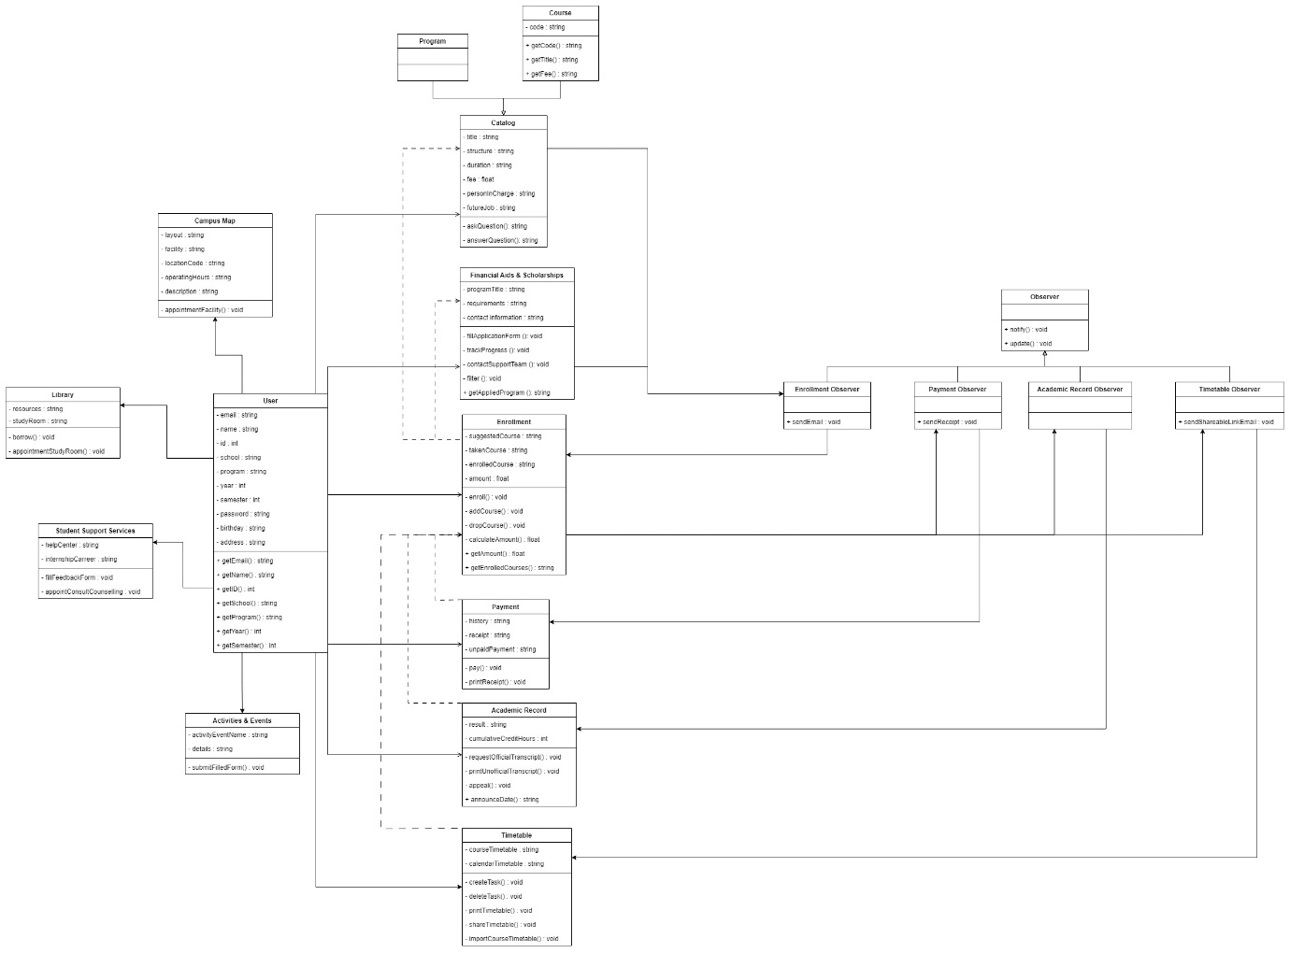

Figure 3.1: The figure shows the UML diagram created for the system.

Link for class diagram and UML diagram: <https://www.figma.com/file/oQA5umRBmfrpTVgAWqRdIu/class-diagram-student-business-system?type=design&node-id=0%3A1&mode=design&t=9NhF4sqGrPbA175P-1>

**Task 4 – Creating a Prototype User Interface and Usability Testing**

**4.0 Prototype**

Enrollment

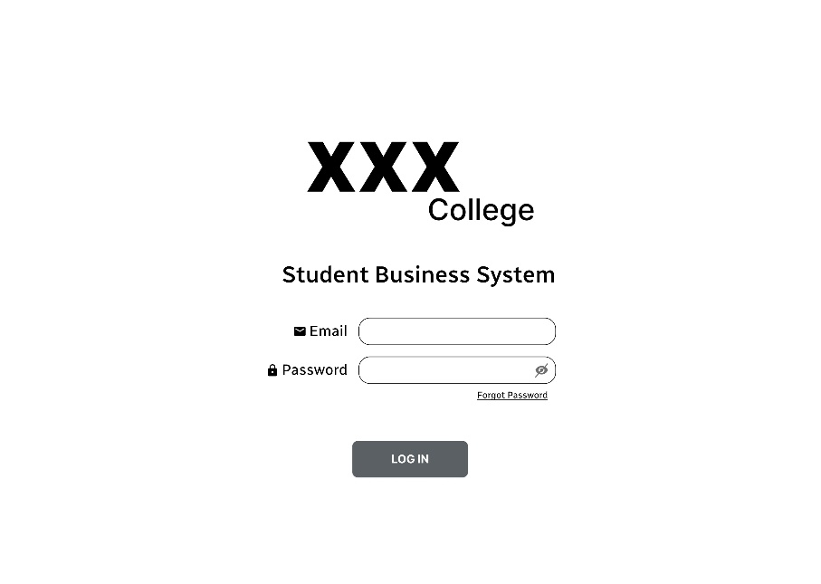

Figure 4.0: The figure shows the login page of the system.

The login page displays the name of the college and system as identification and informs users they are accessing the specific system. Users will get their respective email and password from college for logging in.

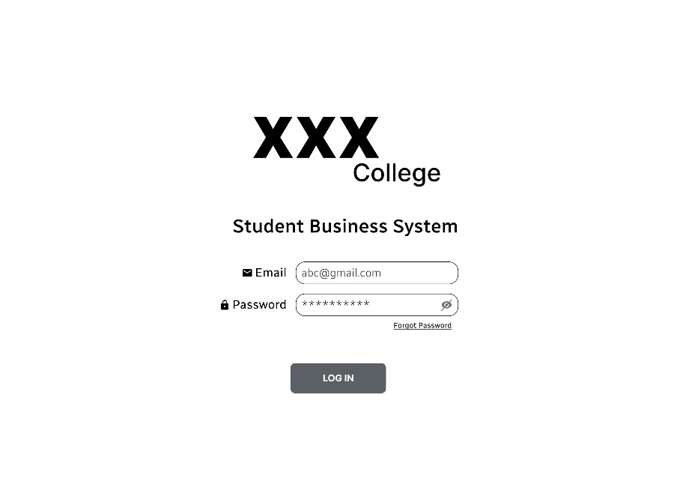

Figure 4.1: The figure shows the initial text structure for user input.

When the user input values in the entry fields, the email is shown normally while the password is shown in asterisks. The purpose of masking the password is to enhance the security and privacy by preventing someone from looking over for a user’s password easily.

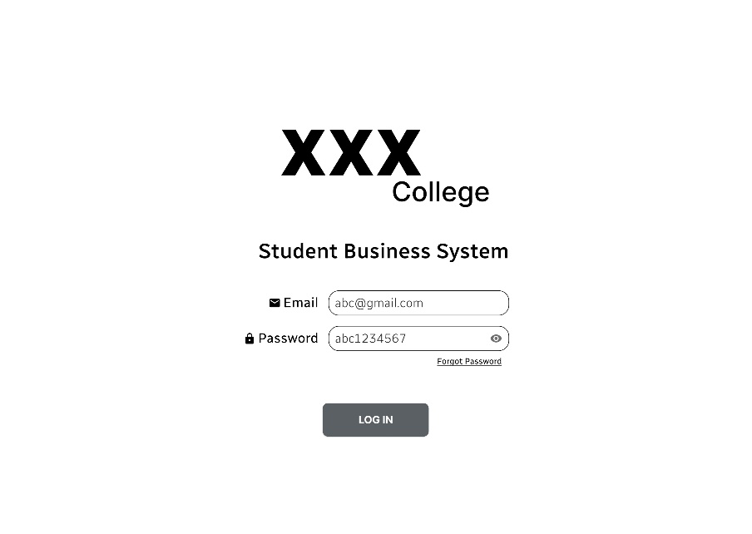

Figure 4.2: The figure shows the text structure when the user clicks on the eye icon for showing password.

However, the system does consider human nature. Initially, the eye icon is with a slash which means invisible password. By pressing on the icon, the slash is removed and users can temporarily display the inserted password for checking purposes.

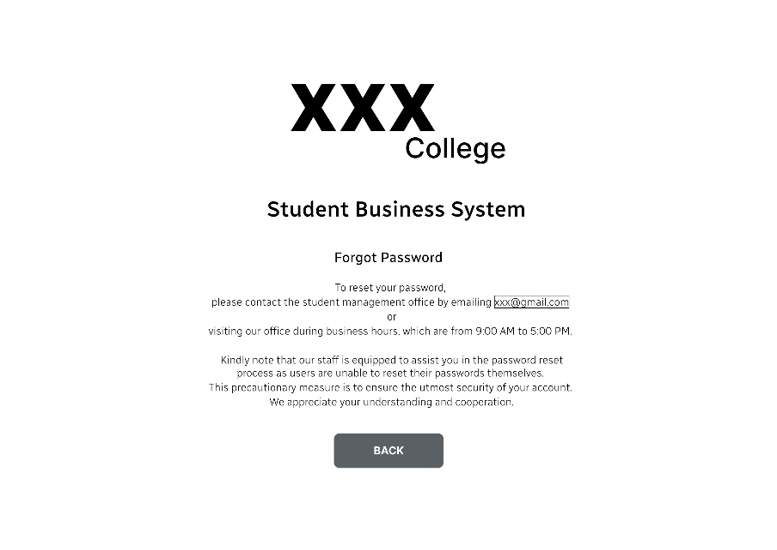

Figure 4.3: The figure shows the forgot password page of the system.

When users click on the underlined forgot password button, they will be navigated to this page informing users that they are unable to reset the password by themselves but need to contact the respective personnel at the student management office. The contact information of the student management office is provided as well.

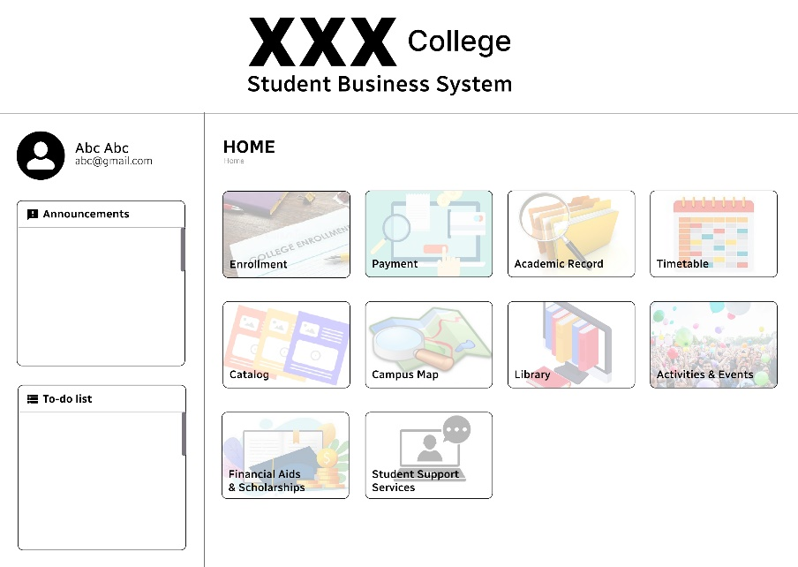

Figure 4.4: The figure shows the main page of the system.

If the email and password entered by users are valid, they will be shifted to the main page after they click on the login button on the login page. All the functionalities in the system are displayed at the left-hand side, enabling easier access and navigation. The right-hand side are separated into three sections. Firstly, the picture, name and email of the logged-in user will be shown. Users can edit their personal information by clicking on any of these three elements. Then it is followed by a list of college announcements and personal to-do list generated based on the user’s calendar timetable.

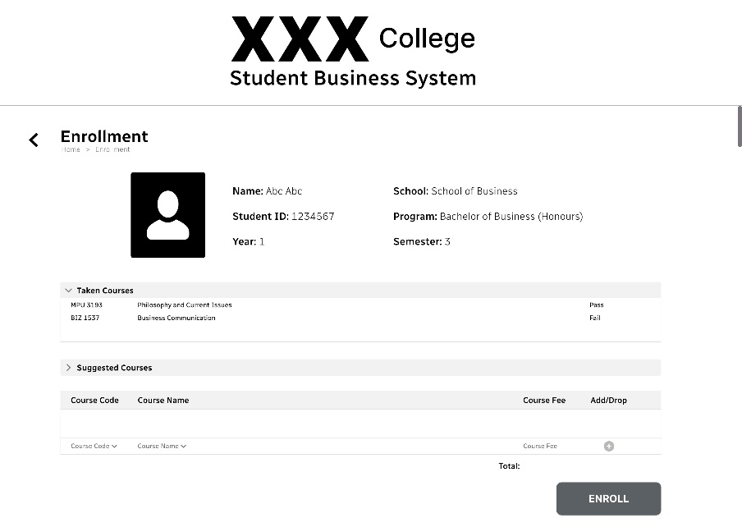

Figure 4.5: The figure shows the enrollment page for the system and the expanded list of courses taken.

The basic academic information of the user such as student ID, school, program, year and semester are shown in this page for identification. The first expandable list is the courses taken by the user in previous year and semester, along with respective status of fail or pass. Based on the status, the user can choose to reenroll in the failed courses or not. This page is with a scrollbar so that users are able to navigate vertically for a complete view.

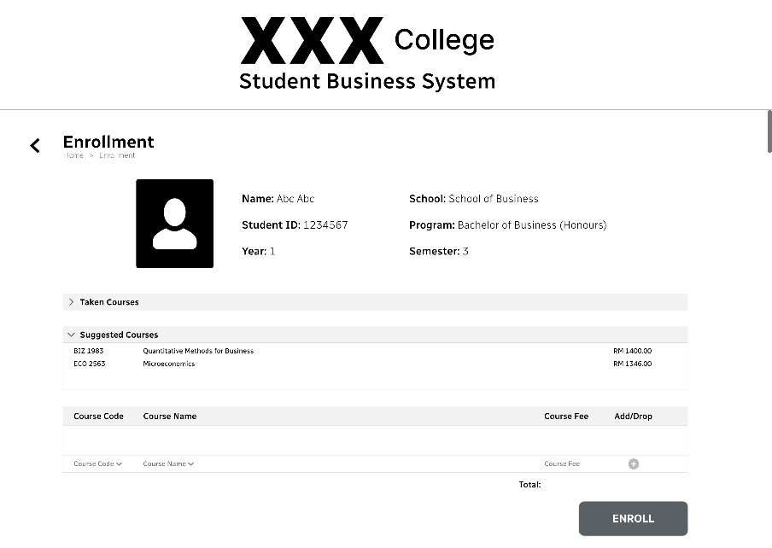

Figure 4.6: The figure shows the expanded list of suggested courses.

The second expandable list in the enrollment page is suggested courses to be taken by the user, providing information such as course code, name and fee. Thus, the user no need to spend additional time searching for information about a relative course.

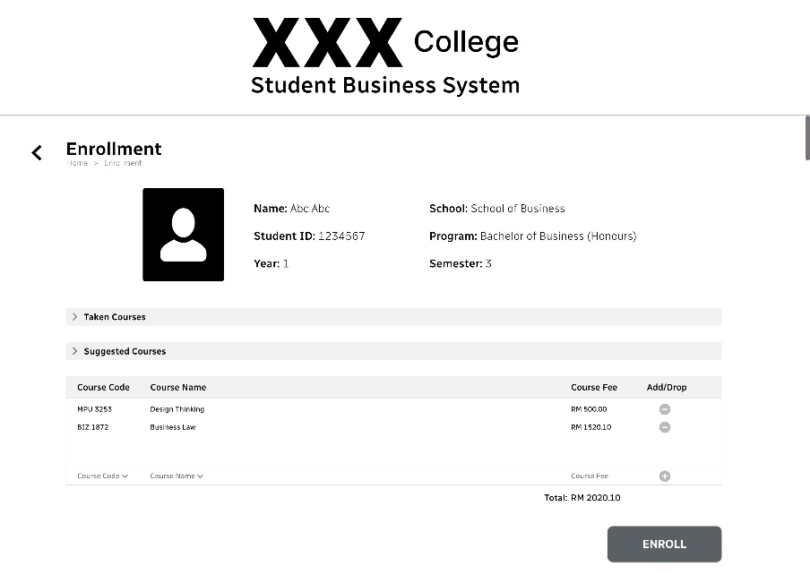

Figure 4.7: The figure shows the layout of the add and drop courses section during enrolling phase.

The section of add and drop courses is located just before the enroll button. A user can search the course by code or name and then click on the plus round button to add the course. Similarly, click on the minus round button to drop a course. For initial enrolling in courses, the user is not required to provide a reason for adding or dropping a course.

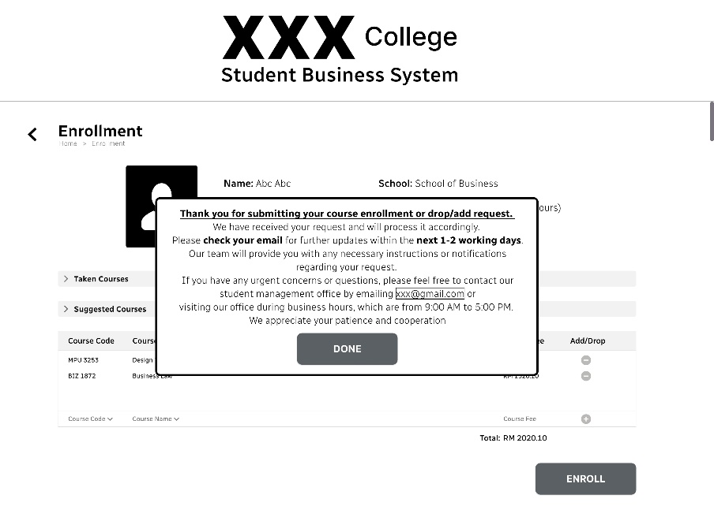

Figure 4.8: The figure shows the notification frame after the user clicked on the enroll button.

By clicking on the enroll button, the system will display a notification frame to inform the user that his/her enrollment request is being processed and remind the user to look for the email regarding the confirmation or further updates about the enrolled courses in 1-2 working days.

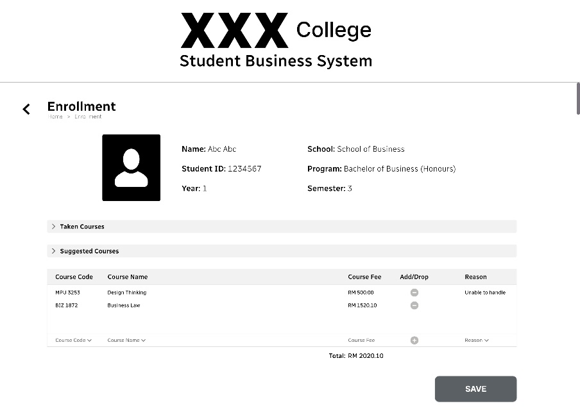

Figure 4.9: The figure shows the layout of the add and drop courses section during the editing phase.

After initial enrollment, the user is still able to modify the enrollment details. The add and drop courses section includes an additional column for a reason. The user can add or drop a course only if he/she provides a valid reason.

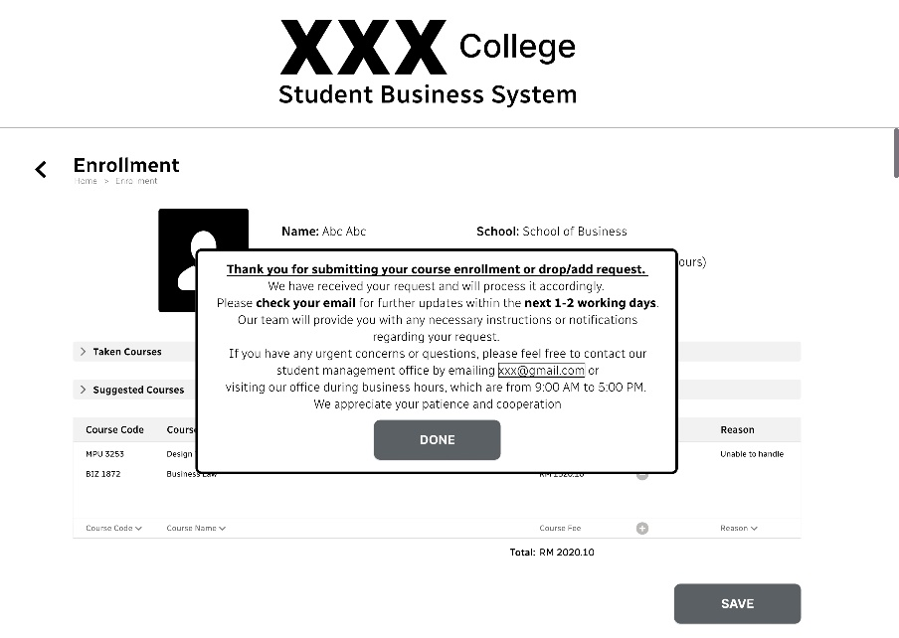

Figure 4.10: The figure shows the notification frame after the user clicked on the enroll button.

Same as initial enrollment, the request of add or drop courses will be processed and reviewed before sending an email to the user. The notification frame also encourages users to contact the student management office if they have any inquiries or problems.

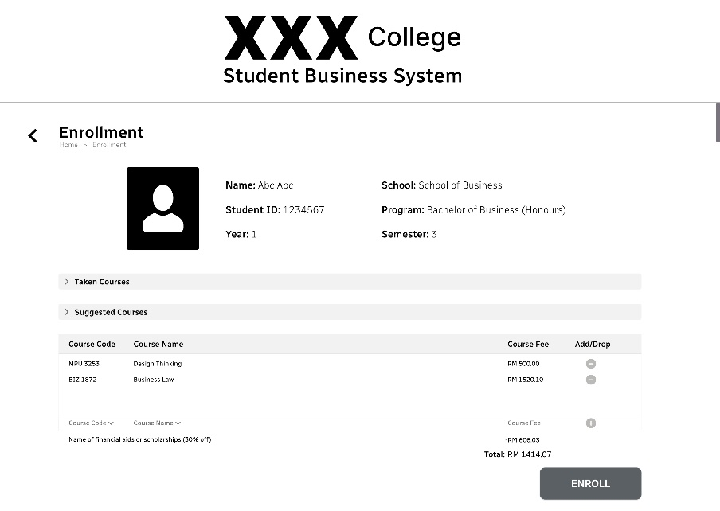

Figure 4.11: The figure shows the deduction due to financial aid or scholarship if any applied by the user.

If the user has successfully applied for any financial aid or scholarship program, the system will deduct the corresponding amount automatically. The total amount of fee is calculated in real-time, which means it will update immediately when there is a course being added or dropped.

Timetable

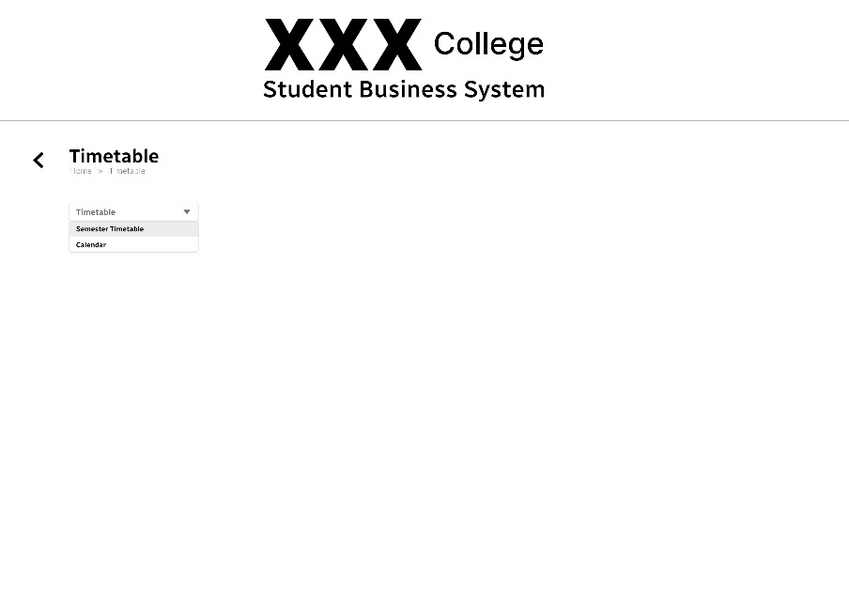

Figure 4.12: The figure shows the timetable page of the system and selection on semester timetable.

Initially the timetable page is almost blank with only one dropdown menu. It is labeled with a descriptive title, ‘Timetable’ in grey-coloured font to guide the user to make a selection on the type of timetable. There are two available choices in the dropdown menu which are semester timetable and calendar.

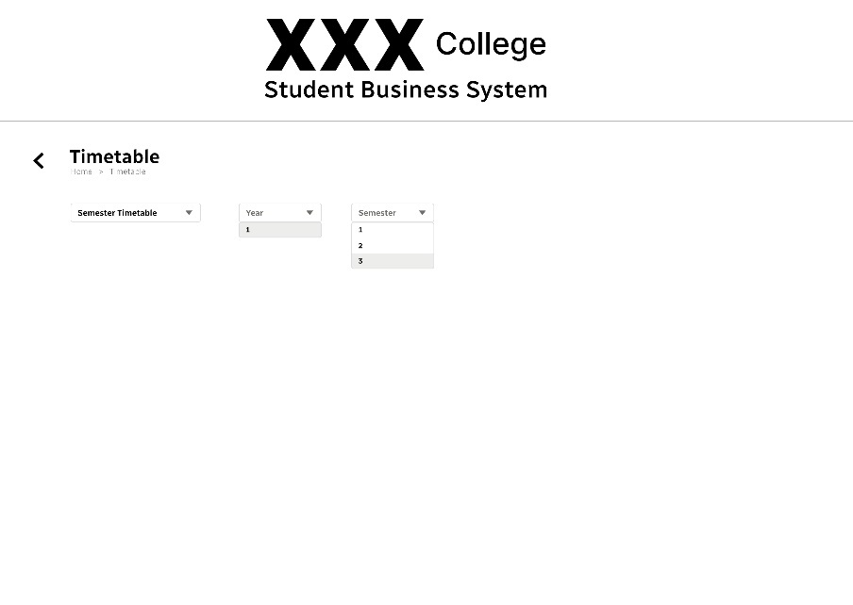

Figure 4.13: The figure shows the further selections for the semester timetable.

If the user selects semester timetable, the title in the first dropdown menu will become black-colored font of ‘Semester Timetable’ and at the same time two more dropdown menus will appear side-by-side to the first dropdown menu. One is for selecting a year while another one is for selecting a semester.

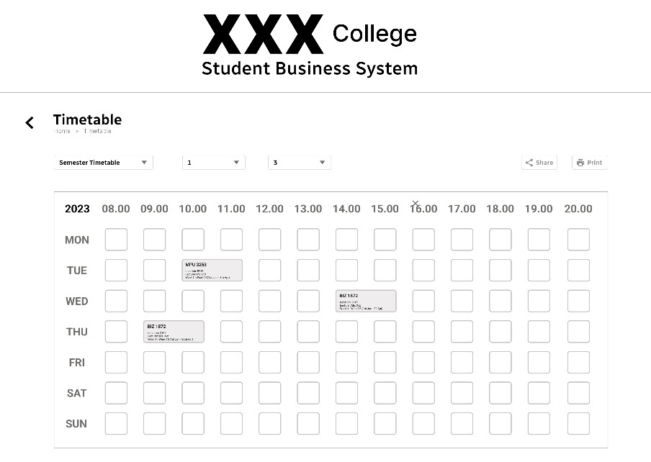

Figure 4.14: The figure shows the layout of the semester timetable.

After selecting year and semester, the system will display the respective timetable for the semester. Each time slot in the semester timetable is represented by a small square. The square will become grey in colour if there is a class within the time. Additionally, if there are two subsequent classes of the same course, the square will be merged. The course code, location, lecturer and duration are displayed within each square. The buttons of share and print are located at the left upper corner with their own functionalities.

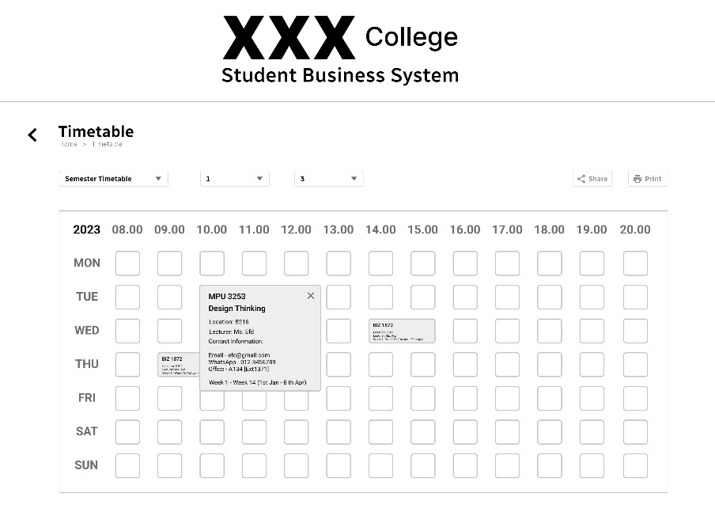

Figure 4.15: The figure shows the detailed layout of a class.

For more detailed information about a specific class, the user can click on the corresponding square and an expanded view will appear. Additional information such as course name and contact information of lecturer are shown. If the user clicks on the cross, the expanded view will be closed and returned back to the square.

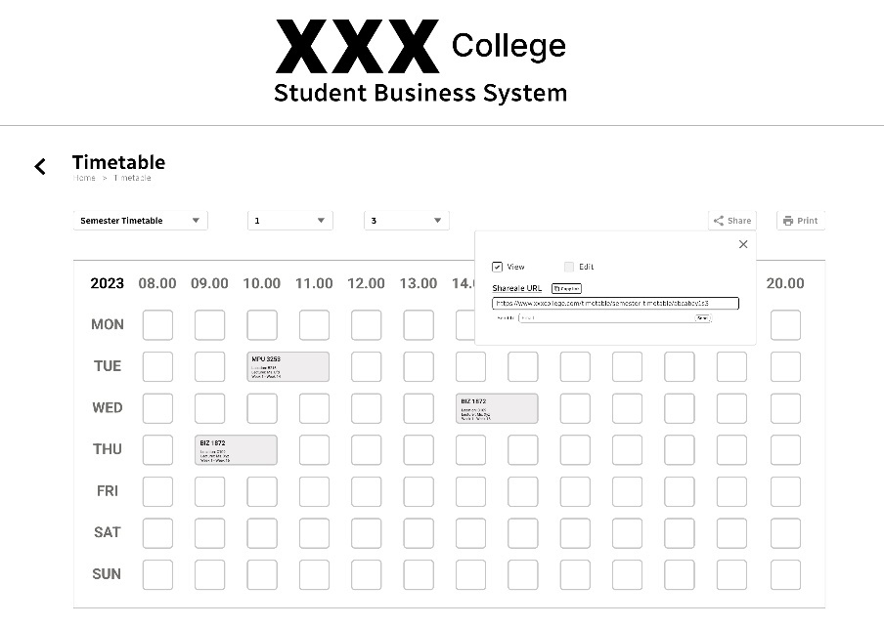

Figure 4.16: The figure shows the frame when the user clicked on the share button for semester timetable.

When the user clicks on the share button, a frame will appear. It included a shareable link as well as checkboxes that allow the user to select permissions for those who access the timetable through the link. The user can choose to copy the shareable link to send externally or directly send the link to the email of the person he/she wishes to share with it. However, the edit checkbox is disabled at here as the semester timetable is generated by the system and the user is unable to make edits to it.

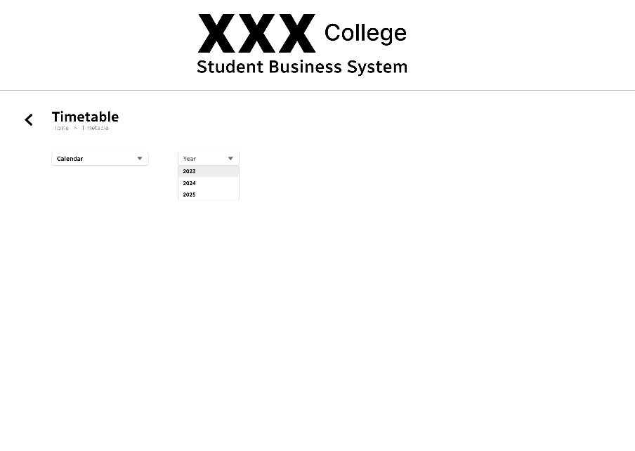

Figure 4.17: The figure shows the further selections for the calendar.

The title of the initial dropdown menu will change to ‘Calendar’ with black colour of font if the user selects calendar. Besides, there will be only one dropdown menu allowing the user to select a specific year for the calendar timetable. The first option of available year is the year which user enrolled in and given two subsequent years as another two options. As each year passes, a new year will automatically be added to the dropdown menu so that the user is able to plan for the current year and also next two years.

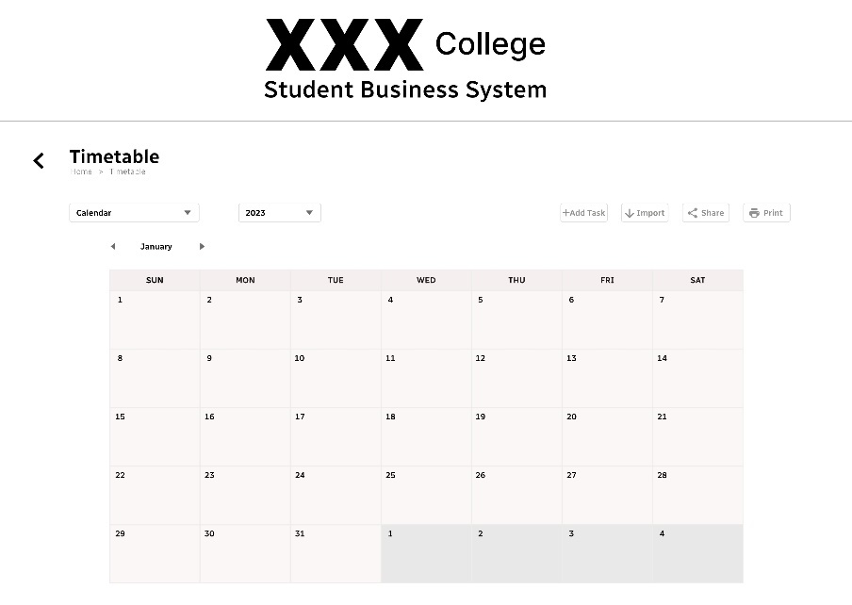

Figure 4.18: The figure shows the layout of the calendar.

After a specific year is selected, the calendar of each year is shown in monthly view. The user can easily navigate between different months using the arrow buttons. There are a total four buttons located at the left upper corner which are add task, import, share and print.

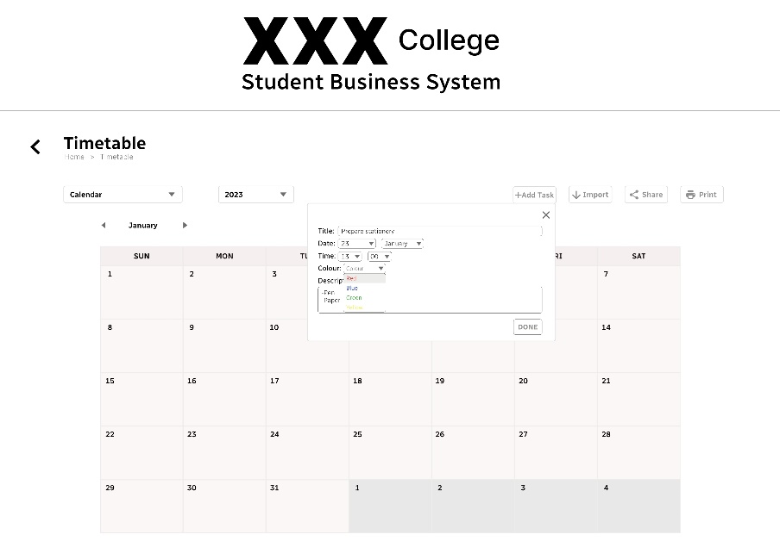

Figure 4.19: The figure shows the frame when user the clicked on the add task button for the calendar.

When the user clicks the add task button, a frame providing simple customization occurs. User needs to fill in the title and description of a new task and select date, time and colour for the task. The selections of colour are red, blue, green and yellow that enables the user to categorize his/her tasks.

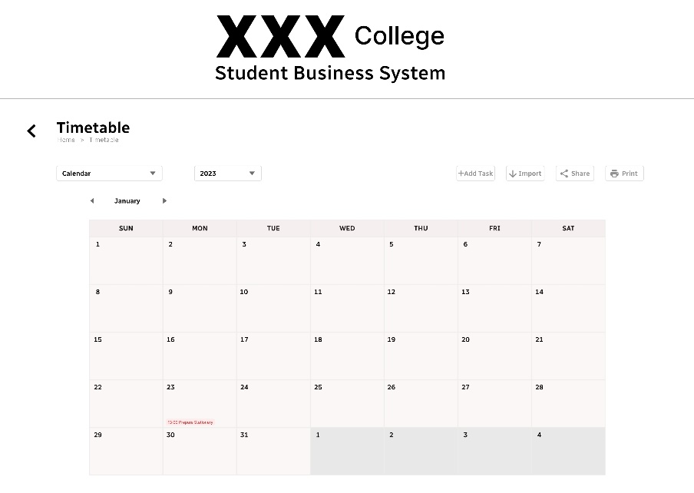

Figure 4.20: The figure shows the layout of the calendar when a new task is added.

The system automatically adds the task into the calendar and schedules it accordingly if the user clicks on the done button within the frame. The task is shown with its title and selected time as a simple representation that enables the user to quickly identify each task.

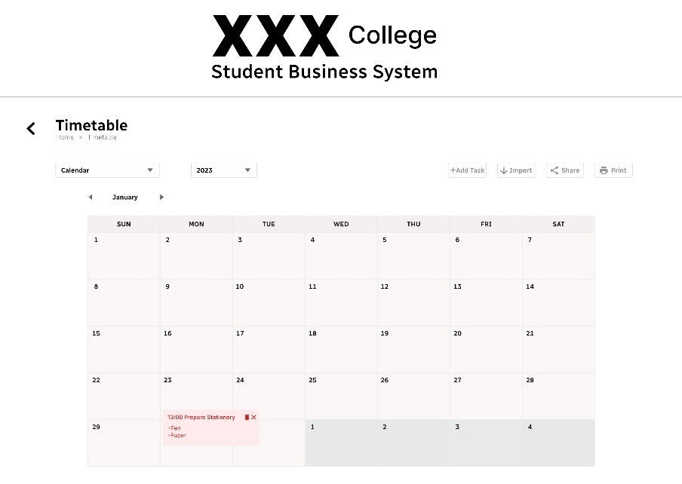

Figure 4.21: The figure shows the detailed layout of an added task.

If the user hopes to obtain the description of the task, he/she can click on the task and it will be expanded. The expanded view can be closed by using the cross icon. Furthermore, the task can be deleted by using the delete icon.

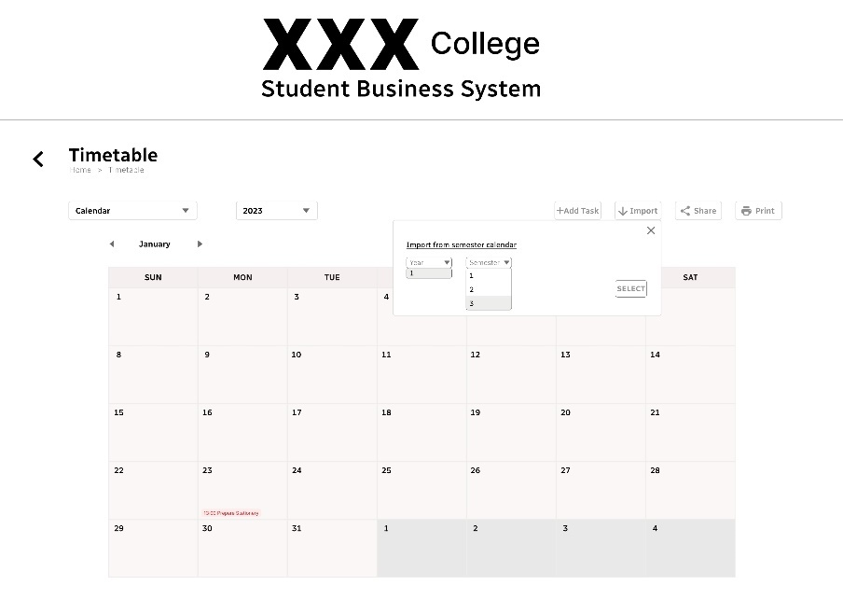

Figure 4.22: The figure shows the frame when the user clicked on the import button for the calendar.

The user can also import the semester timetable of a specific year and semester into the calendar. The only requirement is the semester timetable and calendar must be in the same year. The selections for year and semester are done by using the dropdown menus in the frame.

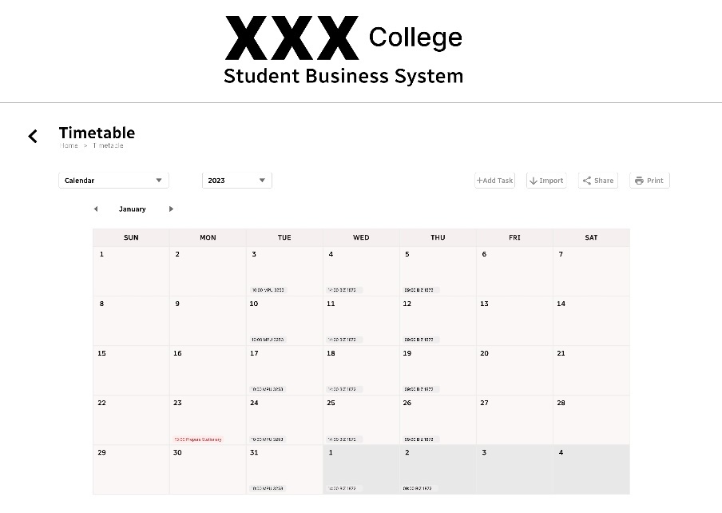

Figure 4.23: The figure shows the layout of the calendar when the semester timetable is imported.

When the user clicks on the select button in the import frame, the respective semester timetable will be imported into the calendar with the arrangements as above. If there is a class on every Tuesday, the system will add the corresponding tasks to the calendar displaying the time and course code of the class on every Tuesday. The imported tasks are light grey in colour so that they do not duplicate with the colours provided.

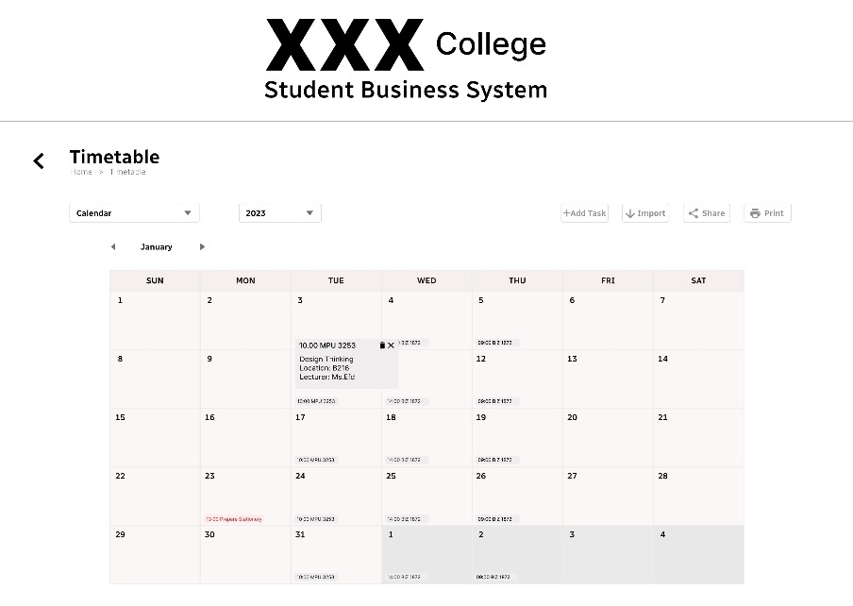

Figure 4.24: The figure shows the detailed layout of an imported task.

If a user wants to get more details about the class, he/she can click on the task for an expanded view. Course name, location and lecturer are shown within the expanded view. Same as others, the expanded view can be closed by clicking the cross icon and the task can be deleted by clicking the delete icon.

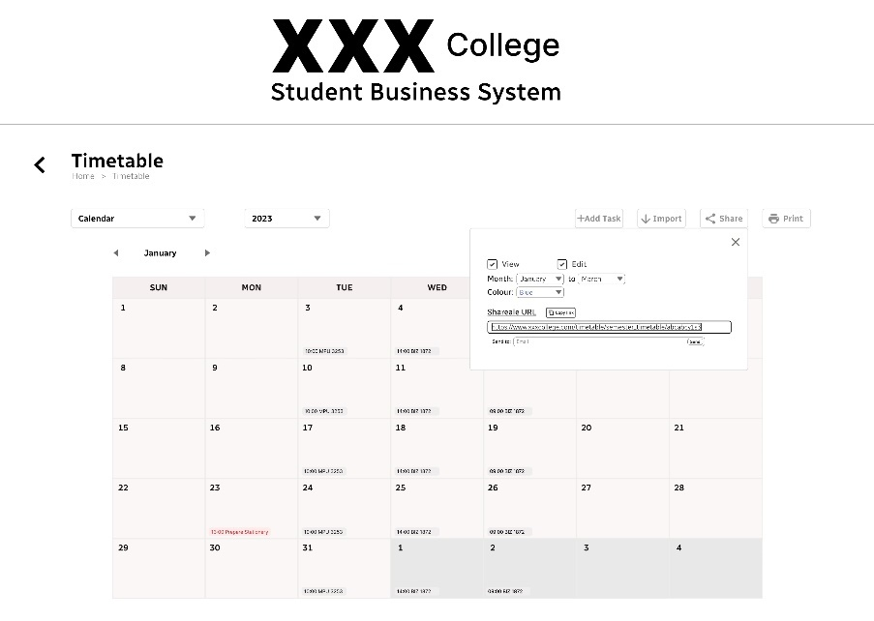

Figure 4.25: The figure shows the frame when the user clicked on the share button for the calendar.

When the user clicks on the share button, a frame with shareable link and options to select permissions for those who access the calendar through the link will appear. Same as the semester timetable, the link can be copied or directly sent via email. The difference for calendar timetable is the user has more options for granting different levels of access, such as view-only or editable within a selected period and specific task colour.

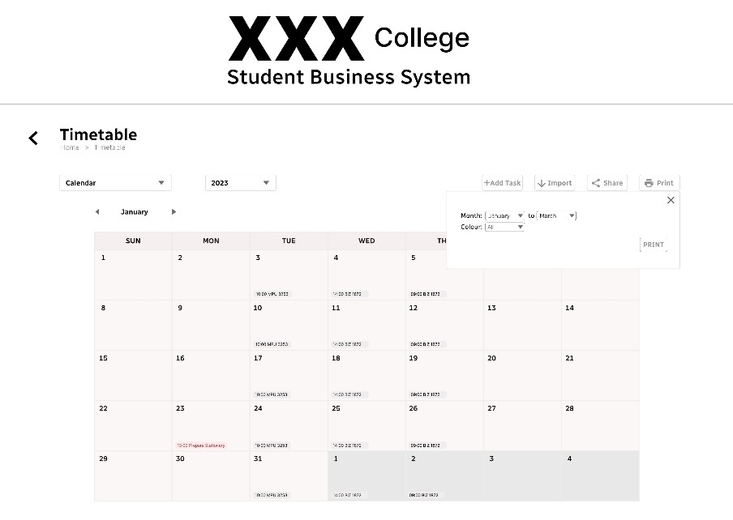

Figure 4.26: The figure shows the frame when the user clicked on the print button for the calendar.

The system does provide a printing feature for a user to have a hardcopy of the calendar timetable by clicking on the print button. User has the options to select a duration period and particular task colour to be included in the printed version.

Link for prototype: <https://www.figma.com/file/fJ0CZZjRHxG38ytf6pgPhO/Prototype-Student-Business-System?type=design&node-id=0%3A1&mode=design&t=z0cO3yQb9TriJGMn-1>

**4.1 Usability testing questions**

Enrollment

1. Were you able to login by using the email and password provided?

Reason: To test whether the login functionality works properly.

2. Did the labels located beside the login entry fields provide clear instructions?

Reason: To evaluate clarity of given instructions for ensuring users are always on the right track.

3. How would you rate the effectiveness of the login process from 1 to 10?

Reason: To obtain a quantitative measure of users’ satisfaction on login functionality.

4. Did the buttons such as login, forgot password and show password perform their respective functionalities well?

Reason: To test whether the buttons are working properly to ensure the user flow.

5. Did you meet any difficulties during the login process?

Reason: To identify if any challenges are faced by users which may be used as ideas for improving the login functionality.

6. Did the main page show all the function sections correctly?

Reason: To evaluate the completeness of the main page.

7. How easy was it to find out the enrollment section within the main page?

Reason: To evaluate the ease of observing the enrollment section based on placement, label and diagram.

8. Did the enrollment page display your academic information correctly?

Reason: To test whether the system is able to display information corresponding to a logged-in user accurately.

9. Were you able to view the courses that have been taken before and respective status?

Reason: To allow users to review their taken courses immediately and avoid them from taking the same course which has already passed.

10. Did the suggested courses presented in a good manner with sufficient information?

Reason: To ensure the courses suggested in an organized structure and relevant details are provided.

11. Were you able to find out the section of add and drop courses?

Reason: To evaluate the ease of locating the section.

12. Were the search option functions well for finding the respective course by code or name?

Reason: To test whether users are able to find a course by keywords in a short time.

13. Did you face any difficulties when enrolling in, adding or dropping courses?

Reason: To understand the problems users faced during the enrollment, add or drop courses and try to refine the system by reducing the problems.

14. Did the system carry out deduction if you have a successful applied financial aid or scholarship?

Reason: To ensure users get appropriate deduction on the total amount if they have any successful applied program of financial aid or scholarship.

15. Did the system display a notification frame for informing you about the requests of enrollment and add or drop courses?

Reason: To ensure users get notified about the next action instead of straight directed back to the main page without any instruction.

16. Were you able to receive an email as a confirmation or further updates on enrollment and add or drop courses requests?

Reason: To make sure users receive at least one email for confirming or updating about their requests.

17. Based on your using experience, how would you rate the enrollment functionality and any suggested improvements for it?

Reason: To get the users’ feedback for further enhancements on enrollment functionality.

Timetable

1. Were you able to find the timetable section in the main page?

Reason: To evaluate the discoverability of the timetable section.

2. Did the title of dropdown menus give instructions clearly?

Reason: To ensure users understand the purposes of dropdown menus correctly.

3. Did the system correctly display the respective timetable based on your selection?

Reason: To ensure the timetable is retrieved accurately by the system for showing purpose.

4. Were you able to get detailed information of a class or task by clicking on it to get an expanded view?

Reason: To test whether the task is expandable or not.

5. For the semester timetable, did the system provide the buttons for share and print functionalities?

Reason: To allow users to share the semester timetable with their friends or be able to print out a hardcopy.

6. For the calendar timetable, were you able to add a task into the calendar?

Reason: To test the functionality of the add task button.

7. Did all the tasks being displayed according to date and time with colour selected?

Reason: To ensure the system is able to arrange the tasks in a well-organized structure.

8. After importing the semester timetable into the calendar timetable, did the system create each task correctly within the specified duration?

Reason: To evaluate the accuracy of the system in generating tasks based on information in the semester timetable.

9. Did the system provide a delete button for tasks in the calendar timetable for removing them from the calendar?

Reason: To test whether the timetable functionality is user-friendly which enables users to delete their tasks in the calendar.

10. Were you able to modify the level of access and permission when you want to share the timetable to someone?

Reason: To evaluate the flexibility given the users for sharing the calendar timetable to others.

11. Were you able to print out the calendar timetable with only the tasks existing between the period and colour selected?

Reason: To ensure the users have the options when printing out the hardcopy of the calendar timetable.

12. How far is your feeling on using the timetable functionality, any suggestions for improvements?

Reason: To get feedback from the user’s perspective and make necessary enhancements.

**Task 5 – Discuss the ethical issue related to the software**

**5.0 Privacy concerns**

In this student business system for college, the privacy concerns arise due to the collection, storage and usage of users’ data such as personal information, academic results and financial details. Therefore, the system is designed with considerations to ensure data privacy and security. First and foremost, the email and password of a user are provided by the college. The uniqueness of the email address makes it independent and separated from other email addresses of the user. Besides, users are unable to change the password easily by themselves through verification code sent by email or phone number. They need to contact relevant personnel in the student management office if they forgot the password. These reduce the risk of potential hacking or unauthorized access.

The system does involve online transactions for payments, hence sensitive financial information of a user is protected in multiple ways. For example, secure payment gateway and double encryption are provided. All the payments are able to transact securely in the gateway, without interception of any unauthorized party. Additionally, the user is required to have another password for accessing the payment section. This password can be reset by users themselves in the setting page via phone or email verification. After each time of resetting, the user will receive an email or message informing that the password has been changed. If the action is not done with the user’s consent, the user needs to report immediately to the student management office in order to take the necessary steps for ensuring the safety of financial information.

The timetable feature in this system has offered sharing functionality for users. As a humanized system, the users are able to alter the tasks and months for access of viewable or editable to be given to other users. Shareable links will be generated based on different levels of access and requirements. To a certain extent, these successfully protect the privacy of the user’s personal schedule.

The privacy policies, terms and regulations of the system are located within the setting page for users to review their privacy rights. Therefore, they can know about how the data will be stored and used for what purposes. For example, in the financial aids and scholarships section, users may be required to fill up a form for applying to respective programs. The information in the form will only be used for identifying whether the user meets the requirements or not. By providing such clear and specific information about the data collection, indicates that the system promotes transparency and makes it easier to build trust with users.

**5.1 Intellectual property rights**

For legal launching of the student business system for college, the intellectual property rights must be considered. If the system is mainly developed for a college, it is common that the ownership of the system belongs to the college as well. However, an agreement between developers and college must be clearly defined before the development starts to avoid dispute in the future. The owner of the system, which is the college, will have full association and control over the system including design, source code, functionalities and such others.

Although the college owns the system, the use of the college’s logo or icon as a trademark for the system still needs to get permission and follow guidelines. For example, the font, colour and size ratio must align with the requirements to ensure a consistent visual appearance and enhance the identity. The developers might need to discuss or consult with respective personnel at the college to get more accurate information about the restrictions to the usage of the college’s icon or logo.

Besides, the system may require various licenses such as commercial software license, database license and digital content license. By having those licenses, the system has successfully prevented unnecessary conflicts related to illegal usage. As an example, there are a lot of books, resources, articles and other literary creations that can be found in the library section of the system. All of the materials are with their own copyrights. Therefore, the system needs to obtain necessary licenses and permissions for the legal usage. Both the ownership of the system and licenses being used in the system will be listed at a section of the setting page for better clarification.

**5.2 Effects on society**

The implementation of the student business system for college surely will bring positive effects to society. From the college perspective, the system is able to streamline and improve the efficiency of the student management process such as enrollment, add or drop courses and payment. This absolutely saves the time and effort of both staff and students as it reduces cumbersome steps like filling in and submitting the form manually. Besides, the system is able to validate student actions automatically. If there are any incorrect values inserted or invalid actions, the system will immediately show an error message for informing the student. Thus, the consistency and accuracy of data can be ensured.

For students who are the main users of the system, they have easier access to essential information about the college and their academics through this system. For example, the system does provide a catalog section for viewing all available programs and courses, academic record section for checking current academic progress and campus map section for showing campus layout and facilities provided. If the students are looking for support on financial or study, they can reach out financial aids and scholarships section and student support services section respectively for applying financial assistance program or appoint consultation.

Some minor disadvantages of this system are technology dependence and different learning curves. Firstly, the system strongly relied on technology. If there is no Internet connection, the users are unable to access the system. Or else if the technical issues occurred or poor Internet connection, the functionalities in the system will not be performed well. The system must be able to afford high demand for requests to prevent it from breaking down. Additionally, not all of the users, including staff and students can get familiar with the new system in a short time. They might meet various difficulties and confusions when adapting to the features. Therefore, the college may organize training for staff and prepare simple tutorials as guidance for students.

**Conclusion**

In conclusion, all the tasks have been done with proper documentation. Each task represented a specific purpose for successfully developing the student business system for college. It begins with gathering the requirements from users and creating an outline that meets the users’ expectations. Then, a visual representation of the system is generated with a specified design pattern towards the problem found in order to have an overview about the system. However, it is also possible to have multiple design patterns in a system if the system is more complicated. The assessment is continuing with the design of the user interface and corresponding questions for testing the functionalities of the system. Lastly, the ethical issues of the system such as privacy concerns, intellectual property rights and effects need to be considered before the real development to avoid chaos. The method of using GitHub to well organize the documentations of the tasks is an effective way to learn about version control. Through this assessment, I got a brief understanding and successfully earned experiences about the planning and designing aspects of a software which are valuable and meaningful to me in the future.

**References**

*Business*. (2023). Cambridge Dictionary. Available at: <https://dictionary.cambridge.org/dictionary/english/business> (Accessed: 20 May, 2023)

*Student Business Systems*. (2023). Swinburne University of Technology. Available at: <https://www.swinburne.edu.my/student-engagement/student-business-systems> (Accessed: 20 May, 2023)

*Student Business Systems*. (2023). Australian National University. Available at: <https://services.anu.edu.au/business-units/division-of-student-administration/student-business-systems> (Accessed: 20 May, 2023)